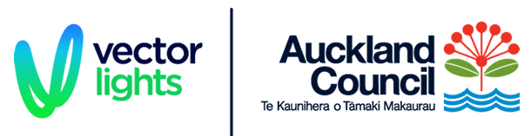

Vector Lights Supporting NZ Charities

Application 2022

Event Name
Event Dates
Charity Contact – Name, phone and email
Is there a specific colour associated with the event?
Outline main partners / sponsors of the event
Are there any cultural or community elements to the activity? E.g. affiliated with any local iwi or community groups? Will there be a physical event taking place – if so, please provide details.
What advertising, marketing or promotional support is planned? Include link to your website and social pages.
If Vector Lights approves lighting the Auckland Harbour Bridge for your event, what role will it play in the event? i.e. a backdrop for photoshoots, physical events, rallies etc.
What outcomes or benefits is the organiser looking to achieve by involving Vector Lights?
Any further information to support your application.

Please email your completed application by 31 August 2021 for applications for the 2022 calendar year to vectorlights@vector.co.nz

