

Planning Bill 2025

and
Natural Environment Bill 2025

Vector Limited Submission

13 February 2026

Table of Contents
Introduction 3
About Vector 3
Planning and electricity distribution networks 5
Planning system architecture 6
Planning Bill 10
Natural Environment Bill 15

Introduction

- This is a submission from Vector Limited on the Planning Bill 2025 and Natural Environment Bill 2025 (together, “the Bills”).
- Electricity distribution is essential to almost every home and business in the country. Vector supports the Government’s intent to replace the Resource Management Act 1991 (“RMA”) with a faster, clearer, more consistent planning system.
- The new system will strongly influence how New Zealanders are able to build houses, grow the economy, and electrify safely and at the least cost. The body of this submission addresses priority matters that we consider essential to support a well-functioning electricity system in New Zealand.
- Vector’s network is extensive by nature – overhead lines and underground cables run through streets, suburbs, rural areas and sensitive environments. Because of this, electricity networks are uniquely exposed to the planning system.
- We need rules that enable routine works, prevent unsafe development too close to live assets, and resolve conflicts between different national directions before they become costly disputes at a local level. Our recommendations are aimed at three outcomes:
    - Safety: preventing incompatible development near live electricity assets and supporting compliance with mandatory safe-distance rules
    - Certainty: ensuring routine maintenance and upgrades can proceed quickly, consistently, and at least cost
    - System coherence: resolve conflicts and unintended consequences early, at the national direction stage, so problems are not pushed down to local government to resolve.
- We consider these changes are aligned with the stated intent of the Bills and will deliver a planning system that enables growth and decarbonisation while protecting the natural environment.
- We wish to have the opportunity to be heard in support of our submission.

Aimee Gulliver
GM Public Policy and Government Relations

About Vector

- Vector Limited is New Zealand’s largest electricity distributor, supplying more than 632,000 electricity connections between Papakura and Wellsford.
Image 1 – Vector network area map
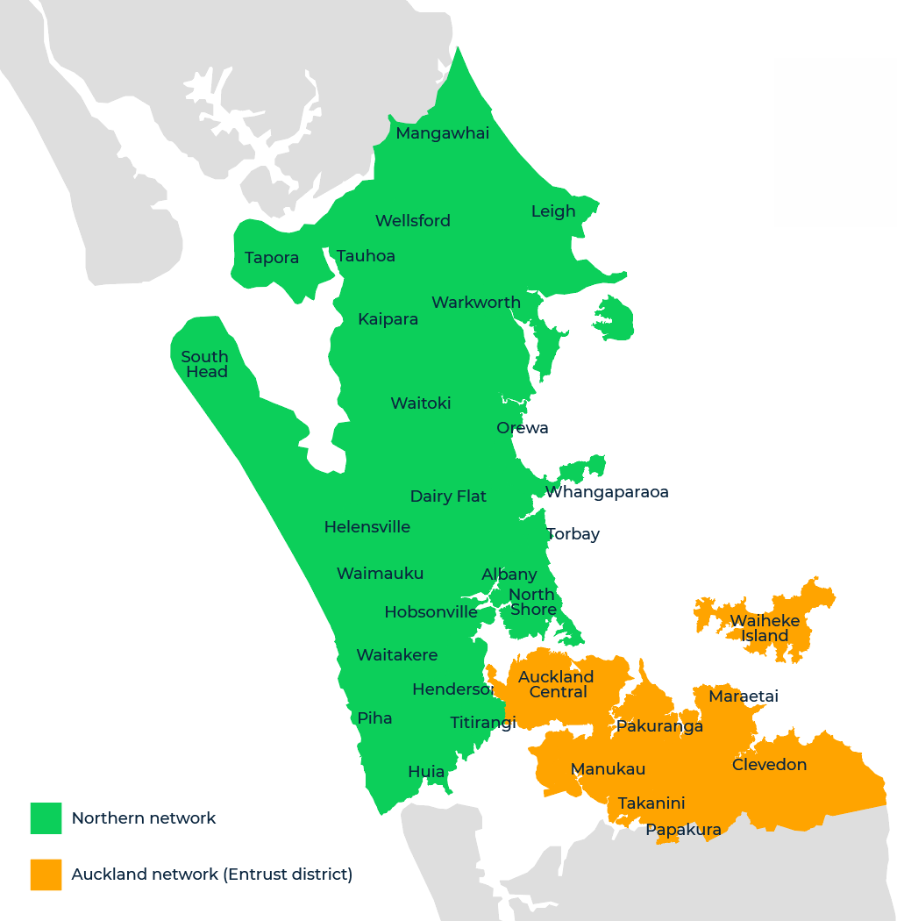
- Vector’s network comprises almost 20,000 km of overhead electricity lines and underground cables, more than 117,626 poles, 23,044 transformers and voltage regulators, and 22,612 switches.
- Images 2 and 3, below, demonstrate the level of high, medium and low-voltage circuits supplying electricity to end-users on our network. This highlights the closely intertwined relationship between the network and its surrounding environment.

Image 2 - Vector high and medium voltage network
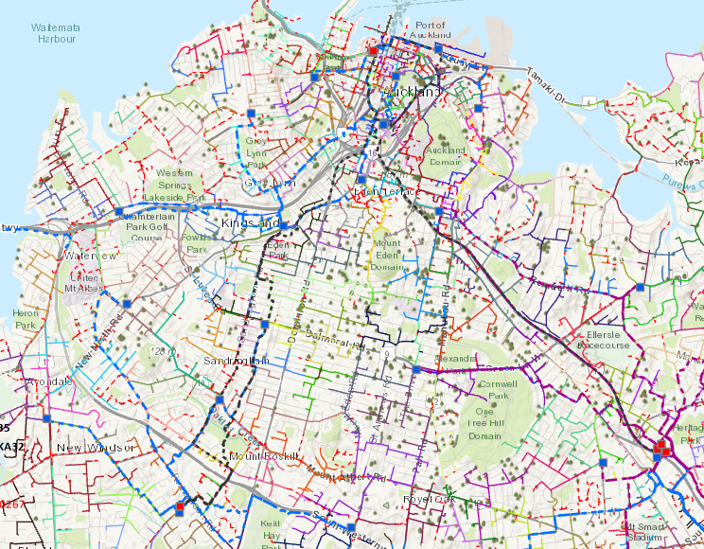
Image 3 – Vector medium and low voltage (last-mile customer supply) network
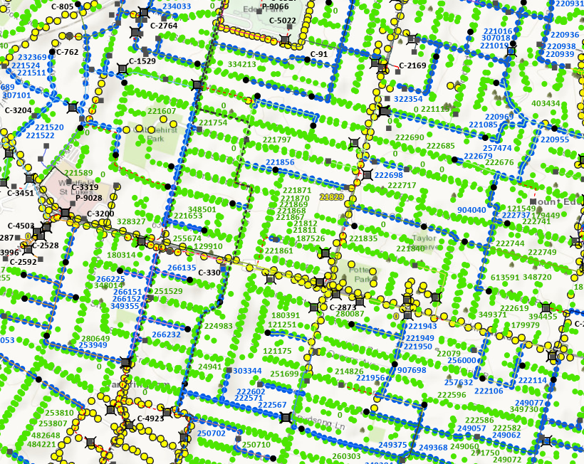

Planning and electricity distribution networks

- Electricity supply is foundational to most development activities currently regulated by the RMA and its replacement by the Planning Bill and Natural Environment Bill. With few exceptions, a connection to an electricity distribution network is fundamental to most land-use development activities, such as residential and commercial development. This makes linear electricity networks uniquely exposed to the planning system, which regulates both how networks are constructed, operated and maintained, and how those environments change around established networks.
- Electricity networks are also central to climate change adaptation and mitigation, providing the infrastructure necessary to decarbonise the economy and reduce emissions from heating, cooking, production and transport.
- Despite the essential functions provided by electricity networks, the close-knit relationship between our assets and surrounding activities, and the anticipated presence of infrastructure assets in all environments, planning policy under the RMA has historically overlooked the fundamental regulatory conditions needed to safely and efficiently distribute electricity. This has resulted in:
    - Arbitrary regulatory barriers to building, maintaining and upgrading electricity network assets required to support third-party land-use development activities;
    - Disproportionately complex and onerous regulatory processes, including mandatory public notification of routine network upgrades;
    - Broad exposure to incompatible land-uses resulting in buildings and structures being constructed dangerously close to electricity network assets in direct contravention of mandatory safety regulations; and
    - An adversarial approach to consenting of routine activities due to perceived amenity effects.
- This has resulted in unnecessary delay, uncertainty and cost to operate electricity distribution networks that are ultimately funded by customers through their monthly lines charges.
- We support the intent of the Bills to create a planning system that results in:
    - greater consistency in planning documents;
    - fewer, faster plans;
    - fewer consents / permits and more permitted activities;
    - less public notification;
    - less duplication;
    - streamlined designation processes; and
    - faster and cheaper dispute resolution.
- As the Bills establish the framework for the new planning system, it is essential that they provide as much clarity as possible in their intended outcomes to avoid interpretive issues at the local regulatory level.
- It is also essential that infrastructure with broad public benefit is enabled at the primary legislation level so that the benefits of infrastructure are appropriately realised at the lower levels of the system through national direction instruments and local plans. While the recently gazetted (amended 2025) National Policy Statement for Electricity Networks 2008 (“NPS-EN”), and the pending National Environmental Standards for Electricity Networks (“NES-ENA”) are a significant step forward, there is still uncertainty of outcomes around:
    - The sequencing, and timeframes for transition to the new planning system;
    - The process to create and amend national direction instruments, including consultation with infrastructure providers affected by consequential regulatory change; and
    - How conflicts between competing national direction instruments under separate Acts will be resolved in a way that enables and protects the essential functions of electricity networks.
- Our submission is targeted at amendments and clarifications that we believe will support achieving the stated intent of the Bills and is structured as follows:
    - Commentary on the planning system architecture;
    - Specific feedback on the Planning Bill; and
    - Specific feedback on the Natural Environment Bill.

Planning system architecture

National Direction – managing conflicts
- We support the overall top-down structure of the new system that aims to achieve national consistency, with narrower scope for variation and more directive outcomes for matters of national significance.
- If national direction is not sufficiently directive about how conflicts are managed, there is scope for significant unintended consequences. Due to their expansive linear nature, electricity networks more than any other class of activity interact with environments subject to potentially competing national direction, including indigenous biodiversity and freshwater management. Any lack of clarity in how conflicts between infrastructure and competing national direction are resolved will lead to relitigation of issues and inefficiency at the lower levels of the system.
- For the system to operate efficiently, there must be certainty of outcome for the construction, operation, maintenance and repair of linear networks. We recommend that national direction is provided as a cross-cutting function that comprehensively and unambiguously resolves conflict between instruments. We also recommend that a ‘carve-out’ is provided for the essential infrastructure that underpins the land-use activities regulated by the system.
- The separation of national direction between the two Acts (shown in image 4 below) has the potential to increase complexity at the lower levels of the planning system if conflict is not adequately resolved earlier in the system. While there may be variation at a regional / local level in terms of natural characteristics e.g. distribution of significant natural vegetation, the interaction between electricity networks and indigenous biodiversity is an anticipated activity for all electricity networks.
Image 4 – New Planning System
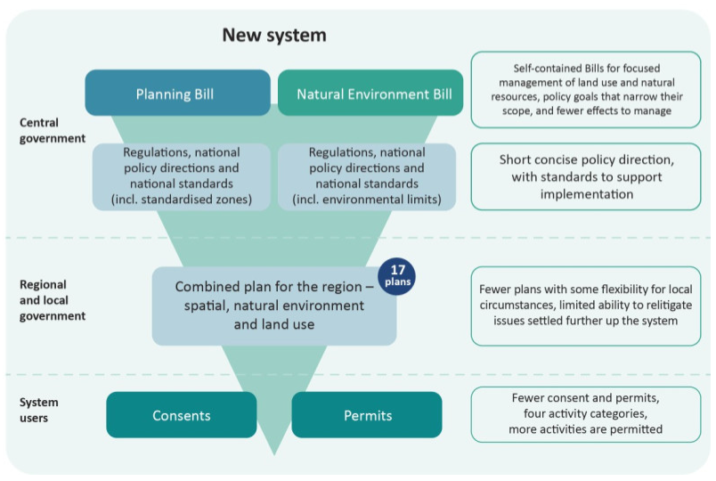
National direction – creation and amendment
- Electricity networks have historically been impacted by the creation of national policy direction in other spheres. The National Policy Statement on Urban Development, for example, has resulted in local authorities being directed to significantly increase urban density with no regard for the safe operating requirements of existing electricity networks. In addition to increasing operational complexity, this has also resulted in direct risk to the public by enabling buildings and structures to be constructed dangerously close to overhead lines in direct contravention of the New Zealand Electrical Code of Practice for Electrical Safe Distances: 2001 (“ECP 34”). While we anticipate the new national direction will provide greater enablement and protection for electricity networks, we are still concerned that the process does not include necessary consultation with potentially affected infrastructure operators to avoid both fundamental incompatibilities and other unintended consequences.
- The opportunity for pre-consultation on industry / sector specific national direction must also be provided to ensure that the final drafting avoids unintended consequences. Despite the significant progress made through the NPS-EN and pending NES-ENA, there is still uncertainty as to the drafting of final provisions of the NES-ENA. Proposed provisions at the time of consultation included descriptions of those provisions without an opportunity for electricity network operators to review the drafting before the instruments are gazetted. This creates uncertainty and lack of clarity in scope, which can be difficult to address or amend once gazetted.
- Similarly, the provisions of other consequential national direction such as the NES National Environmental Standards for Detached Minor Residential Units 2025 (“NES-DMRU”) should stipulate pre-consultation with infrastructure operators to address unintended consequences. The electricity transmission and distribution sectors made submissions recommending standards to require compliance with ECP 34. The NES-DMRU is now in force (15 January 2026) without such essential safeguards. The NES-ENA is expected to include provisions to enforce ECP 34, however as noted in the previous paragraph, the timing and drafting of those provisions are still uncertain at the time of this submission.
- For the above reasons, the creation of new, and amendment of existing natural direction must specifically provide for pre-notification of core infrastructure providers. We recommend the insertion of a new subclause (2) under clause 46 of the Planning Bill and clause 70 of the Natural Environment Bill:
(2) Before the Minister publicly notifies a national instrument, the Minister must—
(a) Provide core infrastructure operators as described in Schedule 5 of the Planning Act with a draft of the proposed national instrument or a summary of it; and
(b) Give core infrastructure operators what the Minister considers to be adequate time and opportunity to consider the document and provide advice on it; and
(c) Have regard to any advice received core infrastructure operators on the document.
- Pre-notification consultation with core infrastructure providers described in subclause (2) could be carried out via existing representative stakeholder groups, such as the Infrastructure Providers Group. This would ensure that any significant unintended consequences or drafting issues can be identified and addressed pre-notification.
- We support the simplified process to efficiently amend national standards to address any errors. We consider that this should be expanded so the process also applies to national policy direction.
- The cross-references in this provision are also incorrect and require amendment. We recommend the following amendments to clause 62(1) of the Planning Bill:
(1) The Minister may amend a national standard or national policy direction without complying with section 70 46 if the amendment is needed for 1 of the following reasons:
(2) Section 69 45 does not apply to amendments made under this section.
- Clause 62(1)(f) limits amendments to changes that are minor in effect, correct errors, or are technical in nature. There is no clear mechanism to review or amend national direction if unintended consequences arise or changes are required to align with industry best practice beyond the current scope of clause 62. This also risks national instruments becoming out of date if best practice standards or methods change. To enable a clear pathway for this, we recommend the following amendments to clause 62(1)(f):
(1) The Minister may amend a national standard without complying with section 70 if the amendment is needed for 1 of the following reasons:
(f) to make changes that are no more than minor in effect, to address unintended consequences, to align with industry best practice, to correct errors, or to make similar technical alterations
- The first tranche of National Instruments only requires 20 working days' notice for submissions (unless the Minister considers further notice is needed). This is insufficient time to consider and meaningfully submit on critical national direction. We recommend the following amendments to clause 7(3)(b), schedule 1 of the Planning Bill:
(b) Those notified (under either Act) must be given 20 40 working days to make submissions on the subject matter of the proposal unless the minister considers that further time is needed.
Regulatory relief
- Vector maintains a neutral position on the provisions laid out in the Planning Bill ‘Part 4 – Regulatory relief’ provided the scope of relief remains limited to the specified topics defined in the Planning Bill and do not apply to the perceived impacts of electricity networks on land values.
- For avoidance of doubt, the planning system must not provide an avenue for landowners to seek relief from network utility operators for perceived loss of land value or utility based on plan-making or consent decisions. Property rights with respect to electricity networks are already appropriately managed through other legislation, such as Part Three of the Electricity Act 1992 with respect to existing works, and the construction of new assets on privately-owned land is otherwise negotiated directly with landowners. The primary legislation for the new planning system must ensure that regulatory relief cannot be used to obstruct or delay necessary works on the electricity network through the planning process.

Planning Bill

Interpretations – Infrastructure
- The definition of “infrastructure” appears to be limited to application within Schedule 5 of the Planning Bill. For both certainty of interpretation and legibility of the legislation, we propose that the definition of infrastructure in Schedule 5 is moved to the interpretation sections of both Bills.
Goals
- The Planning Bill includes provisions that require the separation of "incompatible land uses", including a goal which requires decision-making under the Bill "to ensure that land use does not unreasonably affect others, including by separating incompatible land uses". Regional spatial plans also require consideration of "existing and planned uses that require separation from incompatible activities".
- Whilst we understand that there is no hierarchy in the goals, the wording of clause 11(1)(e) of the Planning Bill “to plan and provide for infrastructure to meet current and expected demand” is not particularly strong in comparison to other goals, several of which use the terms “enable”, and “protect”.
- The drafting is also inconsistent with the content of recent national direction for Infrastructure and Electricity Networks which seeks to explicitly enable and protect infrastructure. The wording of the goal should be consistent with this direction, which will form part of the national policy direction and national standards of the new planning system.
- We propose the following amended drafting of clause 11(1)(e):
(e) To plan and provide for, enable and protect infrastructure to meet current and expected demand.
Permitted activity rules
- The new planning system must recognise the operational realities of linear networks in its approach to regulating permitted activities. There appears to be a drafting error in clause 38(1)(a) which would require all activities classed as ‘permitted’ to be registered with the relevant local authority prior to commencement which would potentially require each of the thousands of permitted activities carried out on the network annually to be registered. This would directly undermine the aim of the Bill to simplify compliance and consenting and would likely result in a system that is more administratively burdensome than the RMA.
- Most of Vector’s daily operational, maintenance, upgrade and repair activities are already permitted in the Auckland Unitary Plan. These activities, with very limited exceptions such as notification of low-volume contaminated earthworks, are not required to be registered with the local authority. When working in the legal road, utilities are already required to obtain works access permits from the road controlling authority or tree owner approvals from the local authority for permitted tree works. These processes ensure that the activities are carried out safely and efficiently with appropriate engagement with the relevant authority.
- We understand that the intent of permitted activity registration is not to capture all permitted activities, and that the scope for a registration threshold is to be determined at the lower levels of the system through national and local planning standards. This intent must be reflected in the drafting of the primary legislation to avoid an overly expansive scope for the registration of permitted activities, which would result in significant burden to the operation of infrastructure as well as administrative burden on local authorities due to the large volume of registrations that would be required to operate electricity networks.
- Additionally, the cross-reference in clause 38(1)(b) appears to be incorrect, and the rule should be much more limited, with registration only applying to certain activities where monitoring is necessary.
- We request the following amendments to clause 38:
(1) A permitted activity rule must-
(a) must require an activity to be registered if required by a national rule; or and
(b) relate to a matter described in section 151 or Part 1 of Schedule 7 may require an activity to be registered if not precluded by a national rule.
(c) must not require any activity undertaken pursuant to a permitted activity rule to be registered if it is undertaken in order to provide infrastructure.
(2) A permitted activity rule referred to in subsection (1)(a) that is required to be registered must provide that an activity is a permitted activity only if […]
Consent processing timeframes:
- Whilst we appreciate the intention of the new system is to increase permissibility and therefore reduce the scope of activities requiring consent to more substantive matters, we are concerned about the framing and proposed maximum durations of consents as follows:
  - The change from 20 working days to 45 working days for non-notified consents in clause 117(3) for the processing of planning consents has the potential to act as a ‘target’ instead of an absolute maximum. This may lead to electricity consents that are currently processed within 20 working days (should they not be otherwise enabled via national direction) being extended to 45 working days arbitrarily.
  - Clause 118(1) appears, without qualification, to establish a timeframe for applications for specified energy activities (which include “any part of the electricity network”) to be “processed and decided” within one year. We understand that the intention of this clause is to ensure complex applications have greater certainty about maximum processing duration, however the framing leaves this open for interpretation and could be read to expand the processing timeframe limit beyond 40 working days. Once lodged, we typically don’t expect consent processing timeframes to exceed three months.
- To address this uncertainty, we recommend that provision is made in the development of natural instruments to set specified maximum timeframes for particular activities where appropriate. Accordingly, we recommend the following amendment to clause 117(1)(b):
(1) The maximum processing time frames for applications for planning consents—
(a) are set out in the table in subsection (3); and
(b) are subject to—
(i) other provisions of this Act; and
(ii) any time frames and excluded time periods prescribed by regulations made under section 282.
(iii) any maximum timeframes for applications for particular activities set out in national instruments.
Planning Tribunal
- We support the establishment of the planning tribunal and expect that this function will deliver consistency in implementation of both national and local planning standards, and improve planning practice, including reviewing the scope of requests for information and the appropriateness of conditions. We recommend that the tribunal is administered in a centralised, nationally consistent model to ensure that national direction instruments are consistently applied regardless of locality.
- In a significant departure to the previous judicial review process under the RMA, the planning tribunal will accept applications from third parties to review notification decisions which would previously have been directed to the High Court, which may result in third parties challenging notification decisions on electricity network operator consent applications through the Planning Tribunal. The provisions for review of notification decisions use the term "applicant" to refer to both the party seeking the review and the party making the application for consent. It is unclear whether this clause, in addition to third parties, enables the party that applied for a consent / permit to go to the Planning Tribunal to review a notification decision, which is the presumed intention.
- Additionally, if a third party applies for a review of a notification decision this will be on the basis that they object to not being “targeted notified” through the consent process and therefore would not have been formally notified of the substantive consent / permit decisions. Clarity is therefore needed so the 25-day period begins from when the substantive decision is notified to the party seeking the consent / permit. We recommend the following amendment to clause 16 of schedule 10:
(1) […]
If the permit or consent application or an application for a proposed designation was not publicly notified, any application for review must be filed within 25 working days after the substantive decision on the application is notified to the applicant the person seeking a consent, permit, or designation
Designations

- We generally support the continuation of a similar structure and administrative process for designating land, with some clarifications and amendments required to ensure that the system is efficient and proportionate.
- Under the new system, designating authorities will be required to prove there is a "strategic need" to secure a designation. There is a potential disconnect between requiring designating authorities to demonstrate this (and allow it to be tested) while elsewhere expressly excluding demand for a project from being in scope of the new system. Works undertaken in the road corridor should not need to demonstrate a strategic need because of the inherent benefits with undertaking additional work in the road corridor rather than elsewhere and the anticipated location of network utility assets in the road as a shared utility corridor. We recommend the following addition to clause 13(4) of Schedule 5:
(4) However, an assessment of strategic need under subclause (2)(e) is not required
if-
[…]
(c) the proposed designation is a project to be undertaken in a road corridor.
- As currently drafted, the Planning Bill requires a territorial authority to "targeted notify" a proposed designation to "affected persons" which includes persons who own or occupy land to which the proposed designation applies. Other provisions allow for effects on parties to be disregarded, however, as it currently stands a party would need to be notified even if it had given written approval. The provisions should be amended to make it clear that an owner or occupier of land is not an affected party if they have given written approval, as follows under clause 20(3)(c) of Schedule 5:
(c) must disregard not consider any person to be an affected person if […]
Relationship between national rules and designations
- We support the intention of clause 42(1)(a) and clause 4(1)(b)(i) of schedule 5 to address a long-standing conflict between national rules and designations created by section 43D of the RMA. Section 43D has had the effect of preventing new designations from being used for activities otherwise regulated by national standards, even where those activities are an integral part of the designated purpose of the site.
- We recommend clause 42(1)(a) is amended as follows:
(1) A designation or a construction project plan may be more enabling than a national rule—
(a) if the standard or rule expressly allows the designation or construction project plan to be more enabling than it;
- We recommend clause 4(1)(b)(i) of schedule 5 is amended as follows:
(1) If a designation is included in a land use plan—
[…]
(b) the designating authority may use land for a project in way that contravenes a national rule, if—
(i) the use of land for the project is authorised by the designation; and
(ii) the national standard or rule expressly allows a designation to be more enabling that the national rule or section 42 otherwise allows the designation to prevail over the national rule; and

- Under clause 42(4) a national rule will prevail over a designation if a construction project plan is required and is not completed before the national rule is made. We recommend that clause 42(4) is deleted to remove uncertainty as to whether the construction project plan for a designation needs to relate to the same aspect of the designation, which otherwise complicates the simple approach laid out in clause 42(2).
Approval from designating authority
- As drafted, clause 42 of Schedule 5 requires a person to apply to a designating authority for approval to do something that would otherwise prevent or hinder the work. If the designating authority does not respond within 40 working days, the application is treated as if it were approved without conditions. This presents some procedural risk as the drafting does not specify how requests are to be received by the designating authority for consideration e.g. by mail or by email / website portal. We recommend the following amendment to clause 43 to ensure a designating authority has genuinely received an application and had an opportunity to respond.
42 Approval to use land subject to designation or proposed designation
(1) A person may apply in writing to the verified address for service of a designating authority that holds a designation for approval to do something in relation to land subject to the designation that would otherwise contravene clause 4(1)(c).
(2) A person may apply in writing to the verified address for service of a designating authority responsible for a proposed designation for approval to do something that would otherwise contravene clause 5(1).
(3) A designating authority must, no later than 40 working days after receiving an application under this clause, notify the applicant in writing of its decision to—
(a) grant approval (with or without conditions); or
(b) refuse approval.
(4) If a designating authority does not notify the applicant of a decision within the deadline specified in subclause (3), the application must be treated as if were approved without conditions.
(5) A territorial authority must maintain a publicly available register of the verified address for service for all designating authorities within its district for the purpose of this clause.
(6) A designating authority must provide the relevant territorial authority with a verified address for service for the purpose of subclause (5).
- We also recommend deletion of clause 28 of Schedule 1 to prevent confusion as to the status of requiring authorities following the transition to the new system.
Construction Project Plans
- Whilst we support the open and transparent publishing of construction project plans (“CPPs”), it would be more administratively efficient and user friendly for CPPs to be published on the website of the relevant local authority. Council websites are already widely utilised to publish information relating to plan changes, notified consent applications and other relevant information of public interest. Members of the public are likely to expect this information to be available on a local authority website. This information is also collated and finalised by the relevant local authority when a CPP is confirmed, and it is administratively expedient for this to be published by the local authority as part of the file closure process. We recommend the following amendments to clause 40 of Schedule 5:
(1) A designating local authority must publish construction project plans provided to it by designating authorities on an internet site to which the public has free access.
(2) A designating authority must provide a plan to the local authority to publish a plan […]

Natural Environment Bill

Interpretation - Industrial or trade premises
- Clauses 21(1)(c) and (d) of the Bill refer to discharges from “industrial or trade premises” but the term is undefined in clause 3 – Interpretations. This is a specific class of activity defined in the RMA, and it is important that a definition is retained in the Natural Environment Bill.
- The scope of industrial or trade premises and associated activities also requires narrowing to prevent it from being applied overly expansively. Industrial or trade premises (and the processes associated with such premises) are predicated on the manufacture and production of products from raw materials that create waste as a byproduct, including the storage of raw materials e.g. distribution and decanting of oils and solvents used in manufacturing processes. While the manufacture of the assets that are deployed on electricity networks, e.g. transformers and switches, is an industrial or trade activity, their use on broadly reaching electricity networks is not appropriately classified as such an activity. Any controls or standards for electricity networks should be addressed through activity-specific provisions in the national standards instead of being broadly classed as industrial or trade premises which more appropriately apply to broader classes of industrial and commercial activities not related to infrastructure.
- To ensure that there is sufficient clarity of the application of this activity classification we suggest that the following amended RMA definition is carried into the Bill:
Industrial or trade premises means–
(a) any premises used for any industrial or trade purposes; or
(b) any premises used for the storage, transfer, treatment, or disposal of waste materials or for other waste-management purposes, or used for composting organic material; or
(c) any other premises from which a contaminant is discharged in connection with any industrial or trade process;–
But does not include any production land or any part of an electricity network.
Goals
- Clause 86 envisages infrastructure providers being able to breach environmental limits however the only goal in the Bill relating to use and development (goal (a)) is “to enable the use and development of natural resources within environmental limits”. This creates a disconnect and potential barrier to permit applications where environmental limits may need to be breached, such as those related to the construction upgrade and maintenance of electricity networks in significant natural areas. To ensure that a pathway exists in the goals for environmental limits to be breached where necessary we propose the addition of a goal “to enable the use and development of natural resources for infrastructure”.

Environmental Limits

- The Natural Environment Bill sets environmental limits to protect human health and the life-supporting capacity of the natural environment. Regional councils will set ecosystem health limits, whereas human health limits will be set nationally. To avoid breaching environmental limits, national standards may require regional councils to implement an action plan, a cap on resource use, or both. If an environmental limit is breached, this breach must be notified, and an action plan must be created to detail how the breach will be remedied.
- National standards are able to create a consenting pathway for "significant" infrastructure that may breach environmental limits. This is essential in ensuring that critical infrastructure has a consenting pathway, however, it is important that the qualifier of "significant" is removed as there is likely to be dispute over what this term means, and the restriction is unnecessary considering that the pathway will be narrowed by national standards. We recommend an amendment to clause 86 as follows:
(1) National standards may establish a consenting pathway for significant infrastructure activities that breach or are likely to breach environmental limits

Permit processing timeframes:
- In line with our comments on the Planning Bill, we recommend the following amendment to clause 138(1)(b) to clarify the scope and intent of the processing timeframes.
(1) The maximum processing time frames for applications for natural resource permits —
(a) are set out in the table in subsection (3); and
(b) are subject to—
(i) other provisions of this Act; and
(ii) any time frames and excluded time periods prescribed by regulations made under section 308.
(iii) any maximum timeframes for applications for particular activities set out in national instruments.
Durations of permits for long lived infrastructure
- The Bill allows coastal occupation permits to have a duration of no less than 35 years (clause 179(1)(2) and no more than 50 years (clause 179(4)(a)). We support increasing the duration beyond the 35-year maximum duration provided for under the RMA, however we question the necessity for a fixed maximum duration on permanent assets with projected operational lifespans in excess of fifty years.
- Vector constructs and operates assets in the coastal marine environment as a routine part of distributing electricity to Auckland’s coastal residents. Depending on the required configuration, this can include constructing or upgrading poles carrying overhead circuits but more commonly involves the installation of submarine cables required to:
    - Add supply diversity and resilience to coastal communities where a landward route is not practicable / feasible such as high voltage electricity circuits between two areas of coastal headland;
    - Construct new, or replace / upgrade existing high voltage electricity circuits to offshore communities such as Waiheke Island to either increase capacity or security of electricity supply; or
    - Cross landward sections of the coastal marine area such as coastal tributaries where these are otherwise indistinguishable from inland river crossings.
- These high-voltage cables are usually subtransmission circuits between major substation sites or otherwise provide necessary capacity and security of supply to large catchments of residents, providing significant public benefit to those residents.
- In all cases, these are long-lived infrastructure assets with projected lifespans of more than fifty years. The function or service provided by the asset, notwithstanding the occasional replacement of the physical components of the asset, has no projected duration or end date. For example, a submarine cable between the mainland and an island community is a permanent service that cannot simply be removed once installed because the residents are dependent on the function provided by the asset and the network operator has a regulatory obligation to maintain supply in perpetuity.
- During normal operation, submarine cables have no ongoing environmental effect. In the event of an upgrade being proposed, a permit to further disturb the seabed would be required at which point any actual or potential environmental effects are able to be addressed in a discreet application addressing the effects of the construction activity.
- We question the utility of imposing a maximum 50-year duration for assets that, once installed, have no ongoing impact on coastal processes as part of their normal operation and for which effects can be appropriately addressed at the time they are repaired, upgraded or replaced. When, at the end of the 50-year duration, the activity and associated occupation are predictably required to continue, this results in further cost and administration to simply continue a long-standing low-impact activity.
- We recommend that clause 179 is amended as follows:
[…]
(6) The provisions specified in subsection (4) do not apply to submarine cables for the transmission, subtransmission or distribution of electricity.
Coastal occupation charges
- In addition to limitations on the duration of coastal occupation permits, we question the utility of levying coastal occupation charges on long-lived infrastructure.
- Under clause 321(1), regulations may be set to prescribe a levy for the taking or use of natural resources after having regard to:
  - the extent to which public benefits from the coastal marine area are lost or gained; and
  - the extent to which private benefit is obtained from the occupation of the coastal marine area.
- The application of a levy in regard to long-lived electricity infrastructure amounts to a revenue gathering activity with no direct relationship to effects from the activity on the coastal environment, and for which significant public benefit is derived. We recommend that clause 321 of the Bill is amended as follows:
(5) A coastal occupation charge must not be imposed on–
[…]
(c) Infrastructure providers

Levies

- We also recommend that infrastructure providers are exempted from levies under clause 313 of the Bill as follows:

(4) the following are exempt from any charges prescribed by regulations made under this section:

[…]

(c) infrastructure providers

https://environment.govt.nz/publications/better-planning-for-a-better-new-zealand
The insertion of the new subclause (2) shifts the proceeding subclauses down e.g. the existing draft subclause (2) becomes subclause (3) and so on.
Planning Bill, clause 11.
Planning Bill, clause 3(1)(h), schedule 2.
Planning Bill, clause 14.

